Software Engineering

Assignment 2

Name : ABID ALI

Roll : 2019380141

**Functional requirements examples**

Looking at some functional requirements examples is helpful to understand what they are. Generally speaking, functional requirements are comprised of both product features and user requirements.

Some examples of functional requirements include:

* Specifications of what the system must do
* Business rules that must be met
* Steps that the system must take in authentication
* Details of what must be tracked in the system
* The reporting requirements of the system
* Specifics relating to legal or regulatory compliance
* Outlines the levels of user and their authorization
* Details of how transactions must occur
* The external interfaces of the system

Thinking about some more specific functional requirements examples, these might include:

1. The system capability to report on the number of transactions that were processed correctly.
2. What the system does when a user selects a certain button where they are taken next.
3. What happens in the event of an attack on the system.
4. The way that a user is authenticated when he or she logs in to the system.

**Non functional requirements examples**

Non functional requirements examples help to better understand what these are. Here are some examples:

**Speed** – how fast the system performs certain activities.

**Availability** – for how much of the time the system is available e.g. does it operate overnight, or every day of the year, or not.

**Capacity** – what the limits are of what the system is able to handle.

**Reliability** – how dependable the system is.

**Usability** – how easy the system is to use for the customer or end user.

Exploring this concept in greater detail, non functional requirements examples might include:

1. The time taken for a specific page to load.
2. The speed within which certain requests must be processed.
3. The level of availability the system should have.
4. Which functions can be performed at different times, and when maintenance will be carried out.
5. How many users the system can handle concurrently.

**UML diagram:**

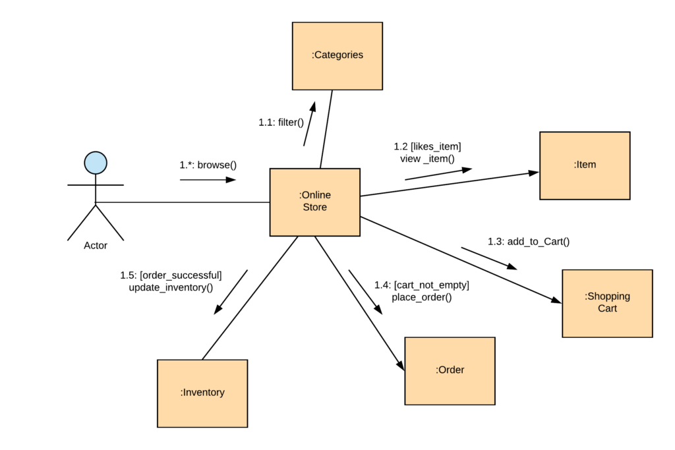

**Activity Diagram:**

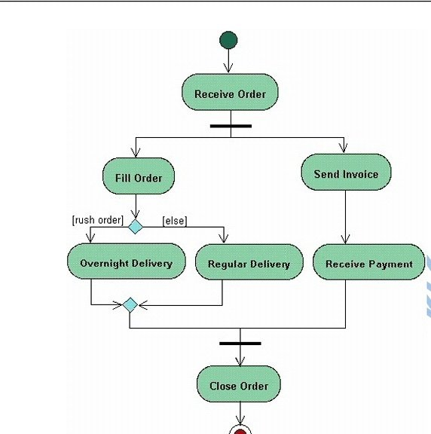

**State Diagram:**

